Chapter 9: River Flooding

Streams and rivers are part of the hydrological cycle

* Surface flow (runoff) finds its ways to streams
* Streams are tributaries of rivers
* A region drained by a single stream is called a drainage basin, watershed, river basin or catchment

Important characteristic of a river

* The gradient – the slope of the surface over which the river flows
  + Determined by calculating its drop in elevation over distance
  + Gradient of the river is greatest at the headwaters, decreases downstream, and is lowest at the river mouth (base level)
    - Base level is the lowest elevation to which the river may erode
  + Slope of a river is shown on a graph showing downstream changes in a river’s elevation – longitudinal profile
* The valley of a river is steeper sided and narrower in its headwaters
* The floodplain is the flat surface adjacent to the channel

Rivers move tremendous amount of material

* Total load – consists of bed load, suspended load and dissolved load
* Bed load – comprises particles of sand and gravel that slide, roll, and bounce along the river channel in rapidly moving water
  + Less than 10% of the total load
* Suspended load – comprises mainly slit and clay particles carries in suspension above the river bed
  + Nearly 90% of the total load and gives rivers a muddy appearance during high flow
* Dissolved load – comprises electrically charged atoms, called ions, that are carried in solution in the water

River Velocity, discharge, erosion and sediment deposition

* Amount of erosion and deposition depends on stream area (A), velocity (V)) and discharge (Q)
* Discharge – volume of water flowing through a cross section of river per unit of time
  + Units of cubic metres per second
* Changes in area lead to changes in velocity
  + Narrow channels have higher velocity than wide ones
* When a river slows, it deposits sediment creating an alluvial fan (fan shaped body) on land or a delta (triangular or irregular shaped deposit) in water

Channel Patterns & Floodplain formation

* Braided channel pattern – large number of intersecting channel
* Anastomosing channel pattern – two or more channels with stable island or bars where sediment is
* Meandering channel pattern – single channel shaped like a snake
  + Migrate back and forth within a floodplain
  + Velocity if higher on the outside curves, cause erosion – cutback
  + Velocity if lower on the inside of curves, cause deposition – point bar
  + Floodplains are created during overbank flows
  + During avulsion, a river abandons a looping section of the old channel, which is lest as a meander cutoff

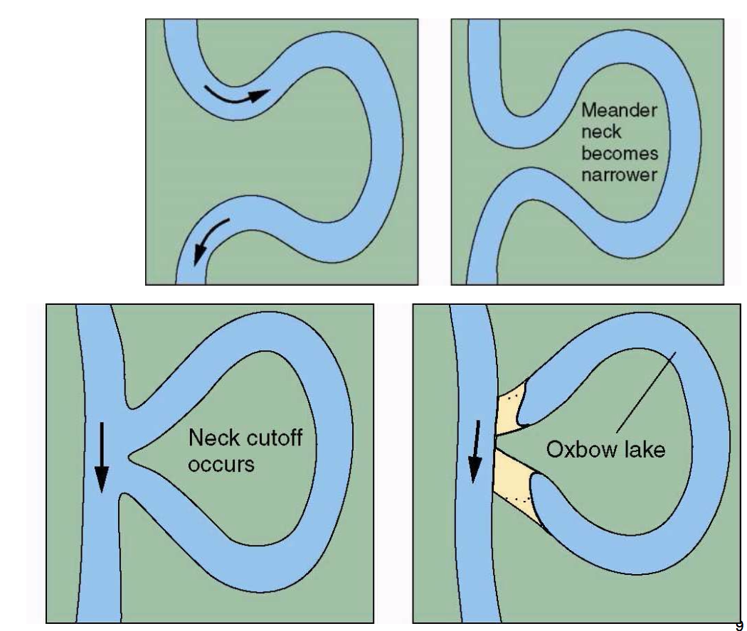

Flooding – overbank flow

Magnitude and duration of the flood is determined by the:

* Amount, distribution, and duration or precipitation in the drainage basin
* The rate at which the precipitation soaks into the ground
* The presence or absence of a snowpack
* Air temperature
* Speed at which surface runoff reaches the river
* Amount of moisture in the soil at the time precipitation starts

Flooding – can happen at different times of the year

* + Ex. Many large rivers flood in late spring after snowmelt
  + Ex. Rivers along the Pacific coast commonly flood in late fall
  + Ex. Ice jam floods occur during break up in spring
* Flooding begins when a stream achieves bankfull discharge
  + The discharge at which water first flows out of the channel
  + Flood discharge – the level of the river surface at a point (or stage)
* Hydrograph - A graph showing changes in discharge, water depth or stage over time
  + Flood stage – frequently used to indicate that a river has reached a level likely to cause property damage
  + Recurrence interval (return period) – the average time between flood events of a certain magnitude

Floods can be characterized by where they occur in a drainage basin

* Flash Floods
  + Occur in the upper parts of watersheds and in small tributary basins of a large river
  + Caused by intense rainfall of short duration over a relatively small area
  + Common in steep sloped arid areas with little vegetation, and following breaks of dams, levees and ice jams
  + most people who die in flash floods are in automobiles
* Downstream floods
  + Affect larger areas than flash floods and are commonly much more destructive and deadly
  + Produced by storms of long duration or rapid melting snowpacks
  + Characterized by a large slow rise and fall of discharge at a particular location
* Outburst floods
  + Are very large, short lived floods and result from the sudden draining of dammed lakes

Glacial Lake Outburst Floods (GLOF)

* Mass wasting event sudden-onset outburst floods that result from failure of a moraine-dam, ice dam or sudden release of water from englacial or subglacial reservoirs
  + Trigger

Breach initiation and development

Downstream routing of the outburst flood wave

Geographic Regions at Risk for Flooding

* Most widespread natural hazard
* Developing countries suffer much greater loss of life than developed ones
  + Large numbers of people at risk
  + Lack of monitoring and warning capabilities
  + Poor infrastructure and transportation systems
  + Inadequate resources available for effective disaster relief

Effect of Flooding

* Damage may be primary (caused directly by the flood) or secondary (resulting from disruption of services)
* Several factors affect the damage cause by floods:
  + Land use on the floodplain
  + Extent, height and strength of dykes
  + Depth and velocity of floodwaters
  + Rate of rise and duration of flooding
  + Season of the flooding
  + Amount and type of sediment deposited by floodwaters
  + Effectiveness of flood forecasting, warning and evacuation

Natural Service functions

* Fertile land – periodic deposits of nutrient-rich sediment enriches the soil for agriculture
* Aquatic ecosystems – floods clear rivers of debris and carry nutrients downstream and into estuaries, increasing the food supply of aquatic organisms
* Sediment supply – flooding keeps the surface of a delta plain above sea level

Human interaction with flooding

* Land Use Changes
  + A river generally maintains a dynamic equilibrium – overall balance between the work the driver does and the sediment load it received
  + Maintains the gradient and cross sectional shape that provides the flow velocity it needs to move sediment load
  + Land use changes can affect equilibrium
    - Ex. Forest to agriculture increases the amount of sediment deliver to a stream (gradient increases, the stream will flow faster until it can carry a greater amount of sediment)
    - Ex. Agriculture to forest will result in opposite
* Dam Construction
  + Upstream of a dam, the river deposits sediments forming a delta
  + Downstream water is devoid of sediment and will erode sediment more aggressively
* Urbanization
  + Increased the magnitude and frequency of floods in small drainage basins
  + Reduces stream flow during dry season

Physical Barriers – barriers built to keep flood waters contained

* Earthen levees, concrete floodwalls, reservoirs, floodways that bypass populated areas, storm water retention basins
* Physical barriers encourage development on the floodplain they are intended to protect

Channelization – straightening, deepening, widening, clearing and lining existing stream channels

* Degrades river and wetland ecosystems
* Benefits are greatest in urban areas with a high flood risk

Channel Restoration – attempts to return modified streams to a more natural state by

* Remove urban waste from stream channels
* Protecting existing channel banks by planting native trees and other vegetation
* Re-establishing deeper pools and shallower riffles within channels

Adjustments to the Flood Hazard

* Floodplain regulation – the objective is to maximize the benefits that floodplains offer while minimizing flood damage and the cost of flood protection
  + Ex. Disallow new development that would lessen a river’s access to a floodplain
  + Flood hazard mapping
* Flood proofing:
  + Raising the foundation of a building
  + Constructing flood walls or earthen mounds around buildings
  + Using waterproofed doors, basement walls and windows
  + Installing drains with pumps to remove water
  + Installing ground level windows that open to allow floodwaters to pass through the building without washing it away
* Canada Water Conservation Assistance Act – enable the federal gov’t to provide financial assistance to the provinces and territories for construction of works to conserve and control water
* Canada water act – comprehensive planning including all water uses
* Flood Damage Reduction Program
* Relocating people from floodplains